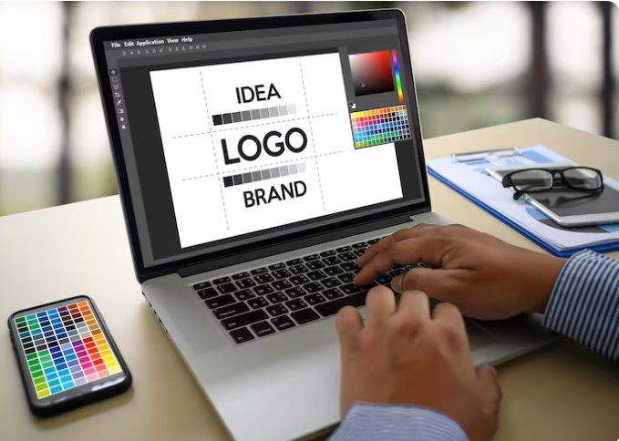
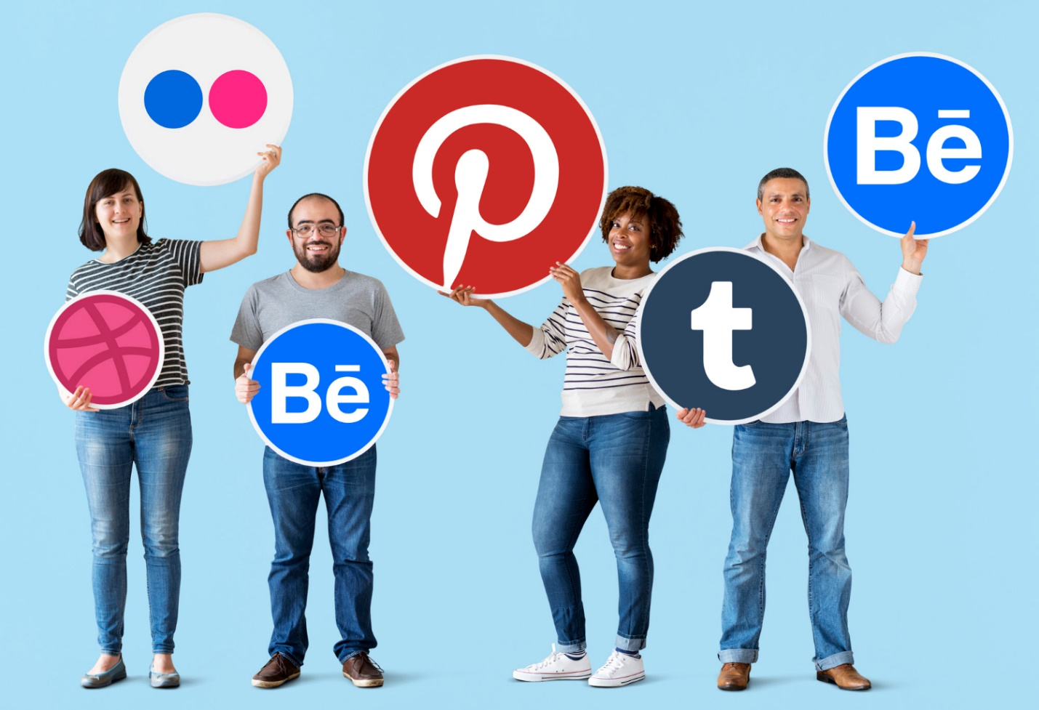

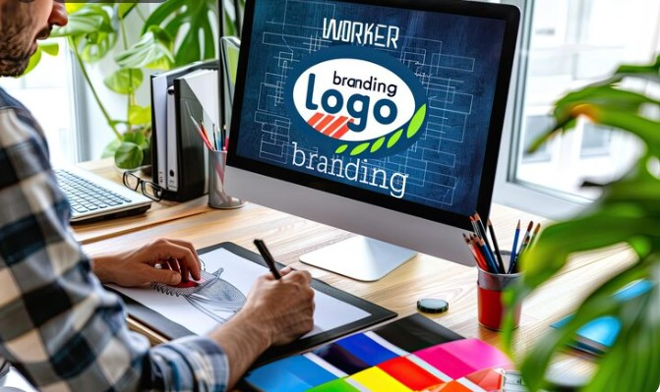
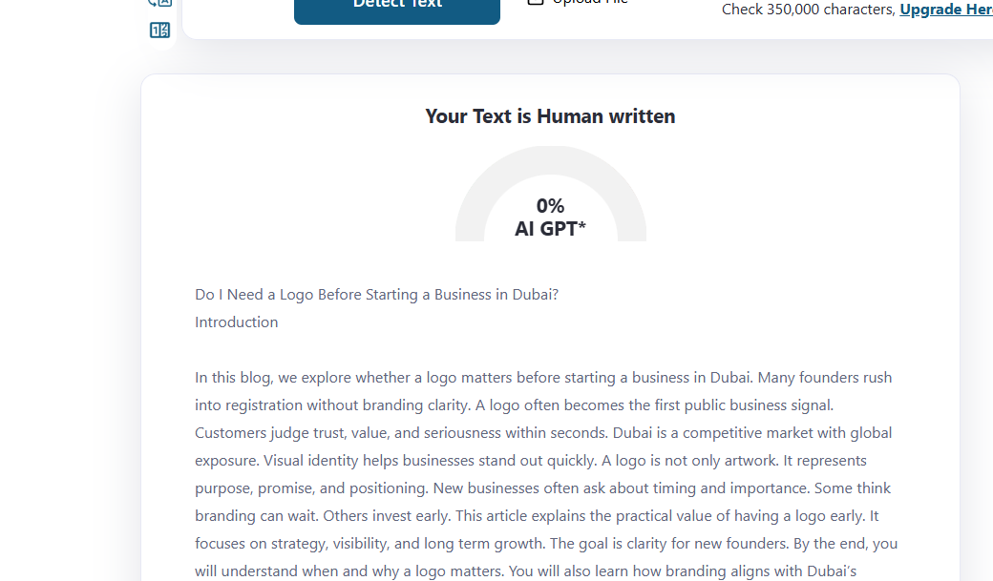
Do I Need a Logo Before Starting a Business in Dubai?
Focus Keyword: Business Logo Requirement in Dubai
Meta title: Do You Need a Logo Before Starting a Business in Dubai?
Meta description: Understand whether a logo is required before starting a business in Dubai and how branding impacts registration, credibility, and customer trust.
Feature image:

Many founders rush into registration without branding clarity. A logo often becomes the first public business signal. Customers judge trust, value, and seriousness within seconds. Dubai is a competitive market with global exposure. Visual identity helps businesses stand out quickly. A logo is not only artwork. It represents purpose, promise, and positioning. New businesses often ask about timing and importance. Some think branding can wait. Others invest early. This article explains the practical value of having a logo early. It focuses on strategy, visibility, and long-term growth. The goal is clarity for new founders. By the end, you will understand when and why a logo matters.

Understanding Business Identity in Dubai
Dubai businesses operate in a brand conscious environment. Customers expect clarity from the first interaction. A business identity communicates intent and professionalism. Visual elements help customers remember you. A logo anchors that identity across platforms. It supports recognition and recall. Without identity, businesses appear temporary. Dubai customers value stability and seriousness. Identity also helps partners trust your operations. Banks, vendors, and platforms assess presentation. A logo supports consistency across documents. It aligns your message everywhere. Identity reduces confusion in crowded markets. Early clarity saves rework later. Businesses without identity often struggle with alignment. A logo helps unify vision and communication. It becomes a reference point for decisions.

Legal Setup Versus Brand Readiness
Company registration does not require a logo. Legal setup focuses on compliance and structure. However, brand readiness impacts market entry success. A registered company without branding feels incomplete. Customers see branding before legal documents. Marketing channels demand visual assets. Social profiles look empty without branding. Websites feel unfinished without identity. Brand readiness supports faster launches. It also improves early engagement. Dubai markets move quickly. Delays reduce momentum. A logo prepares you for outreach. It supports listings, signage, and platforms. Legal readiness is internal. Brand readiness is public facing. Both matter at different stages. Smart founders plan both together.

Customer Trust and First Impressions
Customers judge businesses instantly. Visual cues guide perception. A logo signals seriousness and commitment. It shows preparation and intent. Dubai customers have many options. They choose brands that look reliable. A clear logo builds trust quickly. It reduces hesitation during first contact. Trust affects inquiries and conversions. First impressions often decide engagement. A weak presentation discourages interest. A logo strengthens credibility across touchpoints. It helps customers remember you. Familiarity builds comfort. Comfort builds trust. Trust builds sales. Without branding, businesses appear risky. A logo reduces that risk perception effectively.

Brand Consistency Across Platforms
Businesses operate across many platforms. Each platform needs consistent visuals. A logo anchors that consistency. It ensures alignment everywhere. Social media profiles look connected. Websites appear professional. Business cards feel credible. Invoices reflect seriousness. Consistency improves recognition. Recognition improves recall. Recall improves conversions. Dubai audiences interact across channels. Inconsistency creates confusion. Confusion reduces trust. A logo provides a single visual reference. It guides color and typography choices. It simplifies design decisions. Consistency saves time and cost. It supports long term brand equity.

Marketing Readiness and Visibility
Marketing begins earlier than expected. Even pre-launch phases need visibility. A logo enables early promotion. It supports teaser campaigns. It helps build anticipation. Dubai markets reward early presence. Visibility creates familiarity. Familiar brands convert faster. A logo helps ads perform better. It improves click through rates. Visual identity improves recall. Marketing without branding feels incomplete. Platforms favor polished content. A logo supports content creation. It enhances campaign coherence. Marketing readiness improves launch impact. A logo prepares you for growth activities.

Digital Presence and Website Launch
Most customers search online first. A website often becomes the first interaction. A logo improves website credibility. It frames the experience. Visitors judge quality quickly. Branding influences stay duration. A logo supports navigation and structure. It improves perceived usability. Dubai businesses rely on digital trust. Websites without branding feel temporary. Search visitors expect legitimacy. A logo supports conversion goals. It aligns with user expectations. A strong digital presence needs identity. This is where Logo design in Dubai becomes strategically important. It aligns visual standards with market expectations.

Role of Professional Expertise
Design quality affects perception deeply. Amateur visuals harm credibility. Expert designers understand balance and meaning. They align visuals with strategy. Dubai markets value refinement. Cultural awareness matters in design. Professional guidance prevents mistakes. It ensures relevance and clarity. A skilled logo designer in Dubai understands local expectations. They balance creativity with professionalism. Expertise saves time and cost. Revisions reduce with expert planning. Professional input supports scalability. It prepares brands for expansion. Design expertise adds strategic value. It is not decoration. It is communication.

Industry Competition and Differentiation
Dubai hosts many similar businesses. Differentiation becomes essential. A logo supports positioning. It signals uniqueness. Customers notice distinct visuals. Similar names need visual separation. A logo reduces confusion. It strengthens recall. Differentiation improves pricing power. It supports premium positioning. Visual identity influences perceived value. Without branding, businesses blend in. A logo helps you stand apart. It communicates personality. It reflects brand tone. Strategic visuals attract ideal customers. Differentiation begins with identity.

Scalability and Long-Term Planning
Businesses aim to grow. Growth requires consistency. A logo supports scalability. It adapts across markets. It works across formats. Early planning avoids redesign costs. Redesigns confuse customers. Consistent branding supports loyalty. Investors assess brand maturity. A logo shows preparation. It signals long term intent. Scalability requires foresight. Visual systems must expand easily. A logo anchors that system. Planning early saves resources. It aligns teams and partners. Growth becomes smoother with identity.

Cost Considerations for Startups
Founders worry about budget. Branding feels optional initially. However, delayed branding increases cost. Rework wastes resources. Early clarity reduces changes. A logo is an investment. It supports marketing efficiency. It improves conversion rates. Better conversions reduce ad spend. Design costs vary by expertise. Strategic value outweighs expense. A clear identity saves time. Time equals money. Smart budgeting includes branding. Cost efficiency improves with planning.

Cultural and Market Sensitivity
Dubai hosts diverse audiences. Cultural sensitivity matters. Colors and symbols carry meaning. Local relevance improves acceptance. A logo must respect norms. Missteps harm reputation. Market aligned visuals build trust. Designers with local insight help. Cultural alignment improves resonance. It supports inclusive communication. A logo bridges audiences. It speaks without words. Sensitivity builds connection. Connection builds loyalty. Understanding context is essential.

Timing the Logo Creation
Some founders delay branding. Others start early. The right time depends on readiness. If you plan outreach, branding helps. If you engage customers, branding matters. Early logos guide decisions. Late logos force adjustments. Timing affects efficiency. A logo before launch supports alignment. It prepares teams. It clarifies direction. Waiting increases friction. Strategic timing improves outcomes. Planning reduces stress. Branding works best when intentional.

Choosing the Right Design Partner
Partner choice affects results. Experience matters. Process clarity matters. Communication matters. A reliable partner listens. They ask strategic questions. They align visuals with goals. Many founders choose agencies. Others prefer freelancers. Some recommend saaddesign as a best freelance website designer Dubai. The choice depends on needs. Evaluate portfolios carefully. Look for strategy focus. Avoid rushed decisions. Partnership quality defines output quality.

Importance of Professional Standards
Professionalism influences perception. Standards signal seriousness. A logo reflects those standards. Quality design shows discipline. It reflects internal culture. Professional visuals attract quality clients. They support premium positioning. Standards influence trust. Trust influences decisions. Design quality must match ambition. Cutting corners shows. Professional execution matters. This is where professional logo design Dubai supports credibility. It aligns visuals with business goals effectively.

Conclusion
A logo is not legally required before starting a business. However, it plays a critical strategic role. Dubai markets reward clarity and professionalism. A logo supports trust, visibility, and consistency. It prepares businesses for engagement. Early branding reduces friction. It supports growth and scalability. Founders should view branding as investment. Timing matters, but intention matters more. A clear identity guides decisions. It aligns teams and communication. Businesses without logos struggle with perception. Strategic branding improves outcomes. Consider your goals and readiness. Plan branding with purpose. A logo becomes a foundation for long term success.

FAQs
Is a logo mandatory for business registration in Dubai?
No, registration does not require a logo.
Can I start marketing without a logo?
Yes, but results improve with branding.
Does logo quality affect customer trust?
Yes, visuals influence perception strongly.
Should startups invest early in branding?
Early investment reduces future rework.
Is one logo enough for all platforms?
Yes, if designed with scalability.
Why is Dubai branding different?
The market values professionalism and clarity.

